Name:

### Score: out of

# Manjimup SHS 2015

# Year 11 Mathematics Methods

# Test 7

# Introduction to Calculus

**29**

**Non-Calculator Section (No calculator nor notes, formula sheet is provided)**

**Time: 30 minutes Marks: 29 marks**

1. [4 marks]

Consider the graph of the function y = f(x). Use the features of this graph to answer the following questions.



1. List all stationary points.
2. State the points of inflection.
3. Highlight the sections with a negative value of 
4. Which point on this curve has the properties that f(x) > 0 and ?
5. [2,2,2 = 6 marks]

Find the derivative of the following functions. Express with positive indices.

1. y =  b) y =  c) y = 
2. [4 marks]

Find the equation of the tangent line to the curve y =  at the point (1,2).

1. [4 marks]

Using first principles, = , show that the derivative of y = 3x2 is 6x.

1. [1,2 = 3 marks]

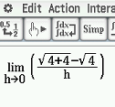

A student types this expression on a Casio display.

1. What function f(x) are they considering?
2. Find the value of the expression on the calculator display.
3. [4,2,2 = 8 marks]
4. Use methods of calculus to find the coordinates of the stationary points of the function f(x) = 3x2 – x3
5. Find the coordinates of the local maximum point..
6. Find the coordinates of the point of inflection.

END OF SECTION 1

# Manjimup SHS 2015

# Year 11 Mathematics Methods

# Test 7

# Introduction to Calculus

Name:

### Score: out of

**26**

**Calculator Section (Calculators and 1 page (A4) of notes permitted, formula is sheet provided)**

**Time: 30 minutes Marks: 26 marks**

7. [4,1 = 5 marks]

1. Determine the rules for the lines that are tangent to the curve y = x2 – 5x – 24 where it crosses the x –axis.
2. Find where these tangent lines meet.

8. [1,2,1,2,2,3 = 11 marks]

A bullet is fired upwards. After t seconds the height of the bullet is found from the rule

H(t) = 150t – 4.9t2 + 2 where t is measured in seconds and H in metres.

1. Find the height of the bullet after 5 seconds.
2. Determine the average speed of the bullet during the fifth second.

Indicate your method.

The speed of the bullet is the instantaneous rate of change of the height of the bullet.

1. Find the speed of the bullet after 5 seconds.
2. Find a rule for the speed of the bullet at any time t.
3. Find the maximum height of the bullet, to the nearest metre. Indicate your method.
4. Determine the bullet’s speed as it hits the ground, on the way down, to 2 decimal places.

9. [1,1,2,2 = 6 marks]

A sketch of f(x) =  has been provided below.

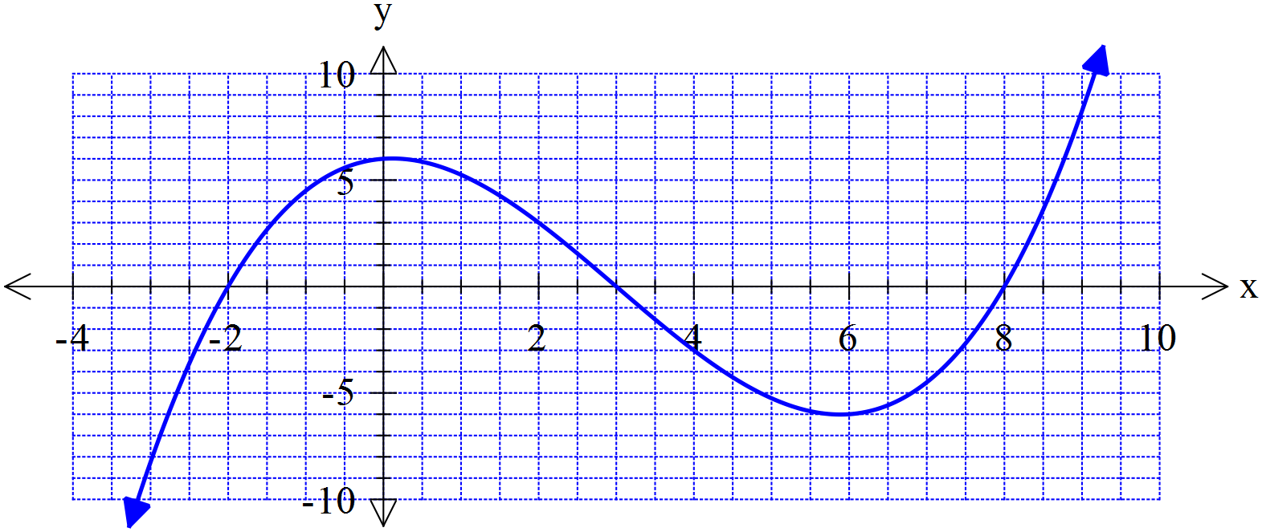

1. What is the average (mean) of the two positive roots of f(x)?
2. On the graph above sketch a tangent line to the curve for the value of x that you calculated in part (a).
3. Find the rule for this tangent line you drew above, that goes through the point where the x-value

Is the average of the two positive roots.

A student has speculated that the tangent line to the curve at the average of two roots also intersects with the third root.

1. Use your answer from part c to show whether this statement is true or false for f(x).

Does this example support the student’s speculation or not? Discuss.

10. [4 marks]

The function y = x3 + ax + b has a local minimum point at (2,3).

Use differentiation to find the values of a and b.

END OF SECTION 2